Project Design Phase-II

Data Flow Diagram & User Stories

|  |  |
| --- | --- |
| Date | 18 july 2025 |
| Team ID | Team id :LTVIP2025TMID32700 |
| Project Name | TrafficTelligence : Advanced Traffic Volume Estimation with Machine Learning |
| Maximum Marks | 4 Marks |

**Data Flow Diagrams:**

A Data Flow Diagram (DFD) is a traditional visual representation of the information flows within a system. A neat and clear DFD can depict the right amount of the system requirement graphically. It shows how data enters and leaves the system, what changes the information, and where data is stored.

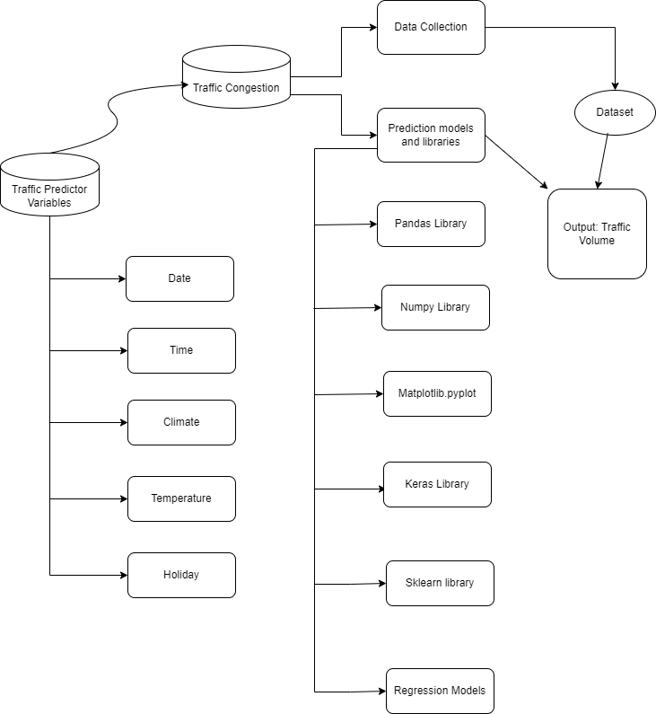

**User Stories**

|  |  |  |  |  |  |  |
| --- | --- | --- | --- | --- | --- | --- |
| **User Type** | **Functional Requirement (Epic)** | **User Story Number** | **User Story / Task** | **Acceptance criteria** | **Priority** | **Release** |
| Traffic Manager | Real-time Traffic Estimation | USN-1 | As a Traffic Manager, I want to access real-time traffic volume estimations to make informed decisions for traffic control. | System provides accurate real-time traffic volume predictions. Data updates occur at least every 5 minutes. Data accuracy is within a 95% confidence interval. | High | Sprint 1 |
| Driver | Real-time Traffic Estimation | USN-2 | Application suggests a approximate congestion in the route. | Application suggests an approximate congestion in the route. | High | Sprint 1 |
| Traffic Analyst | Data Insights on congestion volume | USN-3 | As a Traffic Analyst, I want a Volume number displaying in-depth traffic insights for informed analysis and decision-making. | Volume number showcases traffic trends over various timeframes. | Medium | Sprint 2 |
| Website Developer | Model building | USN-4 | As an Web Developer, I want access to models that integrate TrafficTelligence data for incorporation into existing navigation applications. | Models provide accurate traffic data. Well-documented Models for easy integration. Allows access to real-time and predictive traffic estimations. | High | Sprint 2 |
| City Planner | Customizable Traffic Solutions | USN-5 | As a City Planner, I want customizable traffic solutions to accommodate specific city development needs. | System allows adjustments to traffic control strategies. Customization based on specific traffic conditions. | High | Sprint 3 |
| Educational Institutions | Training | USN-6 | implement data augmentation techniques (e.g., rotation, flipping)  to improve the model's robustness and accuracy. | we could do testing | medium | Sprint 4 |
|  | Testing & quality assurance | USN-7 | conduct thorough testing of the model and web interface to identify and report any issues or bugs. fine-tune the model  hyperparameters and optimize its performance based on user feedback  and testing results. | we could create web application | medium | Sprint 5 |